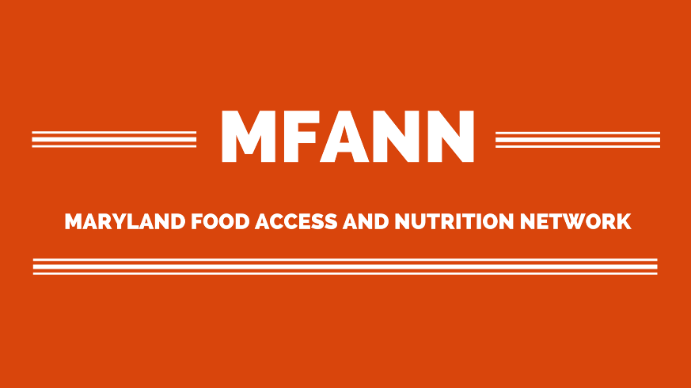

MFANN Fighting Hunger in Maryland: Food for Thought

Conference Scholarship Application

A limited number of scholarships are available for the Fighting Hunger in Maryland: Food for Thought conference on Tuesday October 24 in Annapolis at the Lowe House Office Building (6 Bladen Street Annapolis, MD).

Please complete this application and return it to Amanda Stearns at astearns@mdhungersolutions.org by Friday, October 13. Application should do not exceed 1,000 words.

Name: Organization or School:
Title: Address:
City/State/Zip: Phone Number:
Email Address:

- Please explain why attending the conference is important to you and/or your work.

- Please explain why you should receive a scholarship to attend the conference.

- Please explain how your attendance and participation will contribute to the success of the conference.

